# COMP804 - Assessment 3: Assignment 1 – Task 5

1. Creating a private repository named “Assignment1” in my account named ‘UOWStudent’.

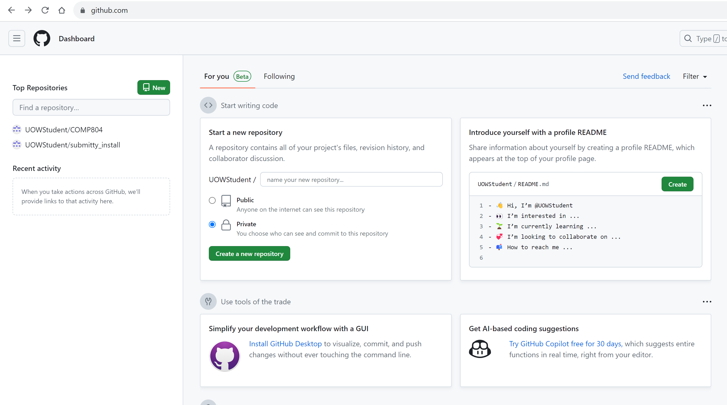

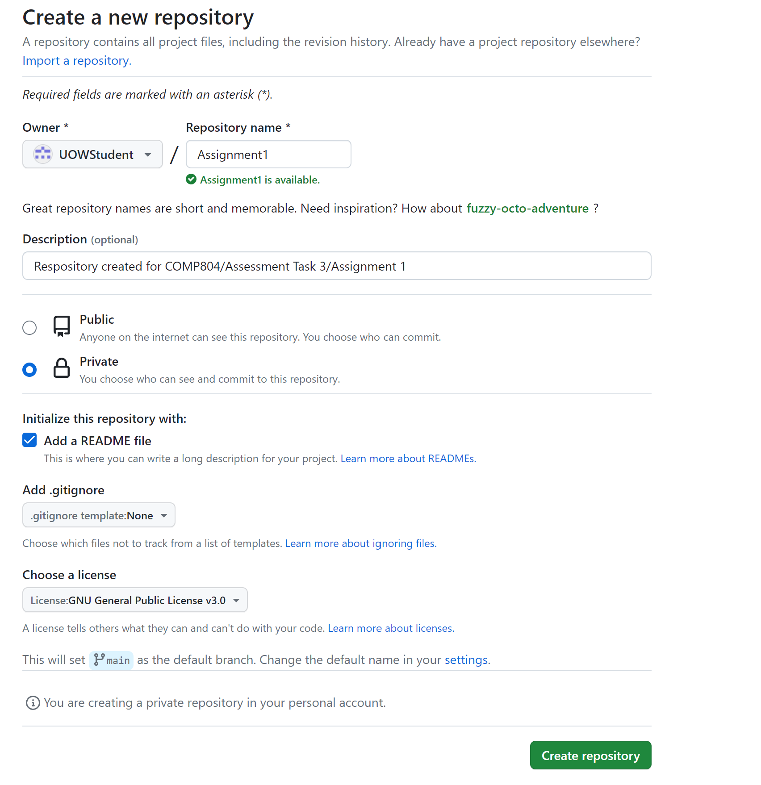

1. Verifying the successful creation of the repository

1. Using Git Bash on my desktop to view the contents of GitHub and clone the Assignment1 repository. I had already set this up in Week 3, which did not require setting up credentials again.

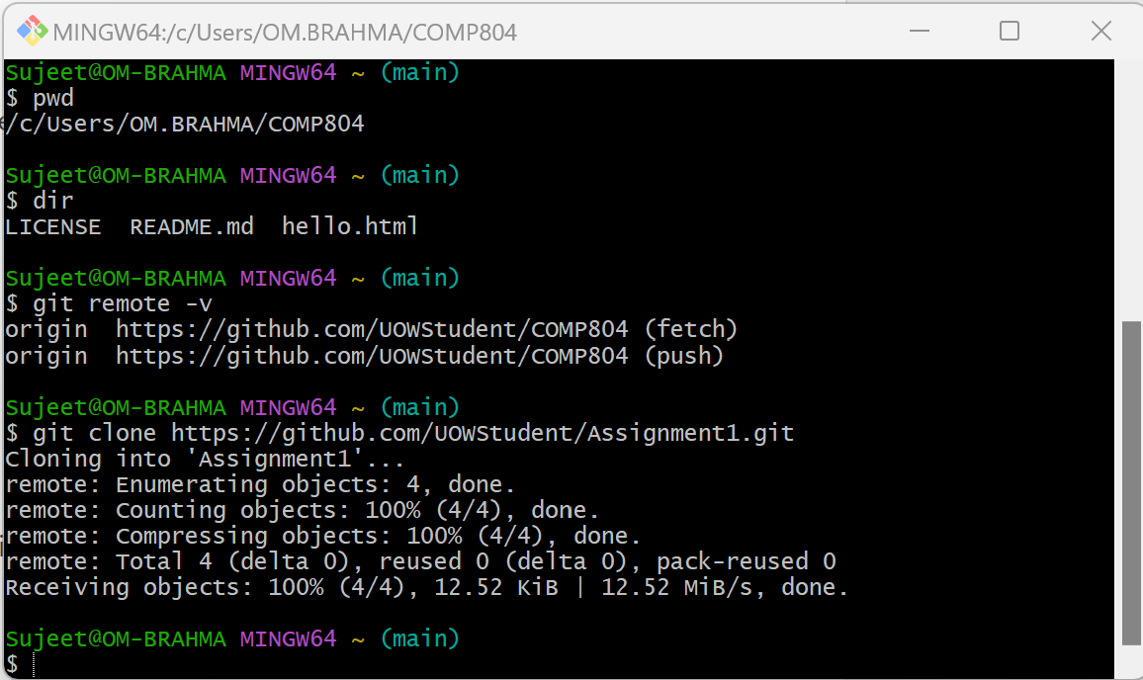

1. Verifying the successful cloning of Assignment1 on my desktop PC and confirming the contents.

1. I added all the assignment files initially to the repository.

1. I initiated a push of all the files and folders and verified that these have been copied over.

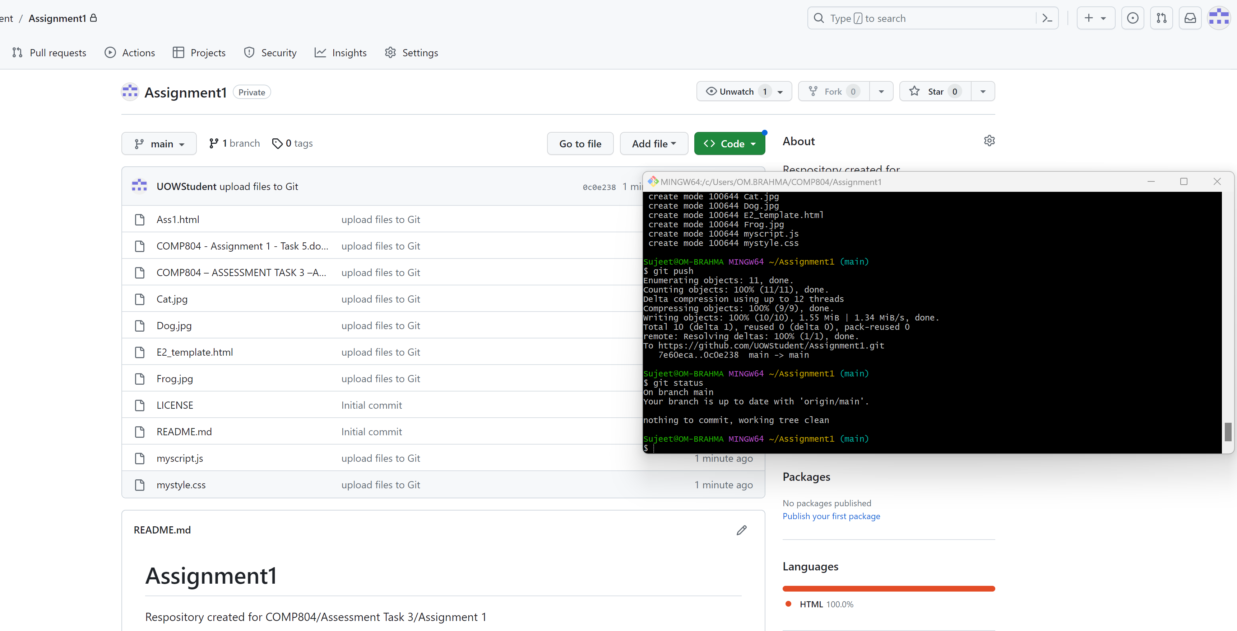

1. I made more changes to Ass 1, mystyle.css and myscript.js, added the files, committed all the contents, and initiated a successful push to GitHub.

1. The link to my repository is:

<https://github.com/UOWStudent/Assignment1.git>